PES University
Software Engineering Laboratory
Lab 2: Agile Backlog Creation & Sprint Simulation in Jira
Clinical Trial Subject Recruitment Engine
Student SRN | PES1UG25CS845
Problem Statement No. | 18
Project Title | Clinical Trial Subject Recruitment Engine
Primary Domain | Healthcare & Telemedicine
Target Actors | Trial Candidate, Clinical Researcher (System Administrator added as a design assumption in Lab 1)
Jira Project | Clinical Trial Subject Recruitment Engine (key: CTRE), Scrum template, company-managed
Source of backlog | Lab 1 Requirements Table (FR-001 to FR-005, NFR-001, NFR-002) and Use-Case Diagram (UC-01 to UC-08)

1. Jira Project Setup
A Scrum project was planned in Jira using the Software development > Scrum template with the Company-managed project type. The project name is "Clinical Trial Subject Recruitment Engine" and the project key is CTRE. The backlog was derived from the functional and non-functional requirements written in Lab 1, so that the Epics, User Stories, priorities and use-case IDs stay consistent across Lab 1 and Lab 2.

2. Epics
The five Lab 1 requirement groups were turned into five Epics. Four Epics cover the functional requirements (FR-001 to FR-005) and one covers the non-functional requirements (NFR-001 and NFR-002).
# | Epic name | Description | Lab 1 source | Stories | Points
1 | Epic 1: Account Registration & Access | Enable trial candidates to register and all users to log in securely, with role-specific access for candidates, clinical researchers and administrators. | FR-001 (UC-01, UC-02, UC-08) | 4 | 13
2 | Epic 2: Clinical Trial Management | Enable clinical researchers to create, edit and close clinical trials and to define the eligibility criteria used to screen candidates. | FR-002 (UC-06) | 4 | 14
3 | Epic 3: Trial Discovery & Application | Enable trial candidates to find open clinical trials, read their details and submit applications that are automatically checked against the trial's eligibility criteria. | FR-003, FR-004 (UC-03, UC-04, UC-05) | 4 | 19
4 | Epic 4: Application Review & Selection | Enable clinical researchers to review the applications submitted to their trials and record an Accepted or Rejected decision for each. | FR-005 (UC-07) | 2 | 8
5 | Epic 5: Security, Privacy & Performance | Protect candidate personal and health-related data and keep the system fast enough for normal use. | NFR-001, NFR-002 | 3 | 11
 | Total |  |  | 17 | 65

3. User Stories by Epic
Each story follows the format: As a [user role], I want [goal], So that [benefit]. The System Administrator story (Story 1.4) is based on a design assumption made in Lab 1; it is not stated in the scenario.

Epic 1: Account Registration & Access
Story title | User story | Priority | Points | Sprint
Story 1.1: Candidate Registration | As a trial candidate,  I want to register an account with my email, a password and basic profile details,  So that I can apply for clinical trials. | High | 5 | Sprint 1
Story 1.2: User Login | As a registered user (candidate, researcher or administrator),  I want to log in with my email and password,  So that I can access the features for my role. | High | 3 | Sprint 1
Story 1.3: Account Lock-out After Failed Logins | As a trial candidate,  I want my account to be locked for 15 minutes after 5 failed login attempts,  So that other people cannot guess my password. | Medium | 2 | Backlog
Story 1.4: Manage User Accounts | As a system administrator (design assumption),  I want to create and deactivate researcher accounts,  So that only authorised researchers can create and manage trials. | Low | 3 | Backlog

Epic 2: Clinical Trial Management
Story title | User story | Priority | Points | Sprint
Story 2.1: Create Clinical Trial | As a clinical researcher,  I want to create a clinical trial with a title, description, location and closing date,  So that suitable candidates can discover and apply to it. | High | 5 | Sprint 1
Story 2.2: Define Eligibility Criteria | As a clinical researcher,  I want to add eligibility criteria such as age range and required medical condition to a trial,  So that only suitable candidates are accepted for screening. | High | 5 | Sprint 1
Story 2.3: Edit Clinical Trial | As a clinical researcher,  I want to edit the details of an existing trial,  So that candidates always see correct and up-to-date information. | Low | 2 | Backlog
Story 2.4: Close Clinical Trial | As a clinical researcher,  I want to close a trial when enough participants have been recruited,  So that no new applications are received for it. | Medium | 2 | Backlog

Epic 3: Trial Discovery & Application
Story title | User story | Priority | Points | Sprint
Story 3.1: View Open Trials and Details | As a trial candidate,  I want to view a list of open clinical trials and the details and eligibility criteria of each,  So that I can decide which trial to apply for. | High | 3 | Sprint 2
Story 3.2: Submit Trial Application | As a trial candidate,  I want to submit an application for a selected trial with the required information,  So that the researcher can consider me for the trial. | High | 5 | Sprint 2
Story 3.3: Automatic Eligibility Check | As a trial candidate,  I want the system to check my application against the trial's eligibility criteria automatically,  So that I know immediately whether I qualify and which criteria I do not meet. | High | 8 | Sprint 2
Story 3.4: Application Form Validation | As a trial candidate,  I want missing or invalid fields to be highlighted before my application is saved,  So that I can correct mistakes and avoid submitting an incomplete application. | Medium | 3 | Backlog

Epic 4: Application Review & Selection
Story title | User story | Priority | Points | Sprint
Story 4.1: View Applications for My Trial | As a clinical researcher,  I want to view the applications submitted to my trials with each candidate's information and eligibility result,  So that I can review candidates efficiently. | High | 5 | Sprint 2
Story 4.2: Record Application Decision | As a clinical researcher,  I want to mark each application as Accepted or Rejected,  So that the recruitment outcome is recorded for every candidate. | High | 3 | Backlog

Epic 5: Security, Privacy & Performance
Story title | User story | Priority | Points | Sprint
Story 5.1: Secure Data in Transit and Passwords | As a trial candidate,  I want my password and personal data to be protected with HTTPS and hashed password storage,  So that my sensitive information cannot be read by other people. | High | 3 | Sprint 1
Story 5.2: Role-Based Access Control | As a trial candidate,  I want only authorised users to be able to see my health-related data,  So that my privacy is protected. | High | 5 | Backlog
Story 5.3: Fast Response Under Load | As a trial candidate,  I want trial pages and application submissions to respond within a few seconds,  So that I can complete my application without waiting. | Medium | 3 | Backlog

4. Prioritised Backlog and Story Points
Stories are listed in backlog order: High priority first, then Medium and Low, with dependencies respected inside each level. Story points use the Fibonacci scale (1, 2, 3, 5, 8, 13) and reflect complexity, amount of work and uncertainty. Planning poker was simulated by one student, using the points-to-time table in the lab handout as a reference.
# | Story | Priority | Points | Sprint | Reason for the estimate
1 | Story 1.1: Candidate Registration | High | 5 | Sprint 1 | Form, validation, unique-email check and storage. Clear scope, moderate effort.
2 | Story 1.2: User Login | High | 3 | Sprint 1 | Standard authentication, well understood, depends on Story 1.1.
3 | Story 5.1: Secure Data in Transit and Passwords | High | 3 | Sprint 1 | Configuration and standard libraries; well-known practice.
4 | Story 2.1: Create Clinical Trial | High | 5 | Sprint 1 | Form, mandatory-field validation and saving; several fields to handle.
5 | Story 2.2: Define Eligibility Criteria | High | 5 | Sprint 1 | Structured criteria data model. Medium uncertainty because it drives the eligibility check.
6 | Story 3.1: View Open Trials and Details | High | 3 | Sprint 2 | Read-only list and detail pages; low risk.
7 | Story 3.2: Submit Trial Application | High | 5 | Sprint 2 | Application form, saving, unique application ID and confirmation message.
8 | Story 3.3: Automatic Eligibility Check | High | 8 | Sprint 2 | Rule matching on several criteria plus clear messages. Highest uncertainty and testing effort.
9 | Story 4.1: View Applications for My Trial | High | 5 | Sprint 2 | Filtered list and detail view tied to the trial owner.
10 | Story 4.2: Record Application Decision | High | 3 | Backlog | A status update with a date and time stamp.
11 | Story 5.2: Role-Based Access Control | High | 5 | Backlog | Permission checks across several screens; needs a security test set.
12 | Story 3.4: Application Form Validation | Medium | 3 | Backlog | Field-level validation and error messages on one form.
13 | Story 1.3: Account Lock-out After Failed Logins | Medium | 2 | Backlog | Small add-on to the login feature with a simple counter and timer.
14 | Story 2.4: Close Clinical Trial | Medium | 2 | Backlog | A status change plus hiding the trial from candidates.
15 | Story 5.3: Fast Response Under Load | Medium | 3 | Backlog | Needs a load test and tuning; uncertain until the system exists.
16 | Story 2.3: Edit Clinical Trial | Low | 2 | Backlog | Reuses the create form with existing data.
17 | Story 1.4: Manage User Accounts | Low | 3 | Backlog | Simple create/deactivate screens, low uncertainty. Not needed for the core flow.
Totals: 17 stories, 65 story points. Priorities: 11 High, 4 Medium, 2 Low.

5. Sprint Plan
Two one-week sprints were planned with a capacity of about 21 story points each. The stories not selected remain in the product backlog for later sprints (23 points).

Sprint 1 (1 week, 21 story points)
Sprint goal: Users can register and log in securely, and researchers can create trials with eligibility criteria.
Stories committed | Priority | Points
Story 1.1: Candidate Registration | High | 5
Story 1.2: User Login | High | 3
Story 5.1: Secure Data in Transit and Passwords | High | 3
Story 2.1: Create Clinical Trial | High | 5
Story 2.2: Define Eligibility Criteria | High | 5
Total committed |  | 21

Sprint 2 (1 week, 21 story points)
Sprint goal: Candidates can view open trials and apply with an automatic eligibility check, and researchers can view applications.
Stories committed | Priority | Points
Story 3.1: View Open Trials and Details | High | 3
Story 3.2: Submit Trial Application | High | 5
Story 3.3: Automatic Eligibility Check | High | 8
Story 4.1: View Applications for My Trial | High | 5
Total committed |  | 21

6. Simulated Sprint Progress
Task progress was simulated by moving stories from To Do to In Progress to Done on the Jira Active sprints board, following the log below. Jira records the actual date and time of each move, so the Jira burndown charts in Section 7 show the real timing.
Sprint | Day | Board movement (To Do → In Progress → Done) | Points remaining
Sprint 1 | Day 1 | Start sprint. Move 1.1 and 1.2: To Do → In Progress. | 21
Sprint 1 | Day 2 | 1.1 and 1.2: In Progress → Done. Move 5.1: To Do → In Progress. | 13
Sprint 1 | Day 3 | 5.1: In Progress → Done. Move 2.1: To Do → In Progress. | 10
Sprint 1 | Day 4 | 2.1: In Progress → Done. Move 2.2: To Do → In Progress. | 5
Sprint 1 | Day 5 | 2.2: In Progress → Done. Complete sprint. | 0
Sprint 2 | Day 1 | Start sprint. 3.1: To Do → In Progress → Done. Move 3.2: To Do → In Progress. | 18
Sprint 2 | Day 2 | 3.2 stays In Progress. | 18
Sprint 2 | Day 3 | 3.2: In Progress → Done. Move 3.3: To Do → In Progress. | 13
Sprint 2 | Day 4 | 3.3 stays In Progress. Move 4.1: To Do → In Progress. | 13
Sprint 2 | Day 5 | 3.3 and 4.1: In Progress → Done. Complete sprint. | 0

7. Screenshots from Jira
Figure 1: Jira backlog with Epics and User Stories
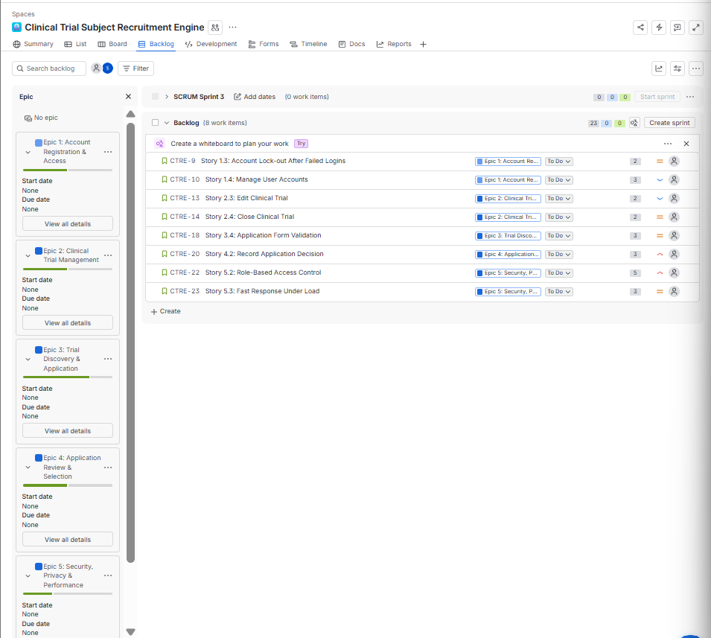
Backlog tab, Epic panel open, all Epics and stories visible with priority icons.
Figure 2: Story point assignments
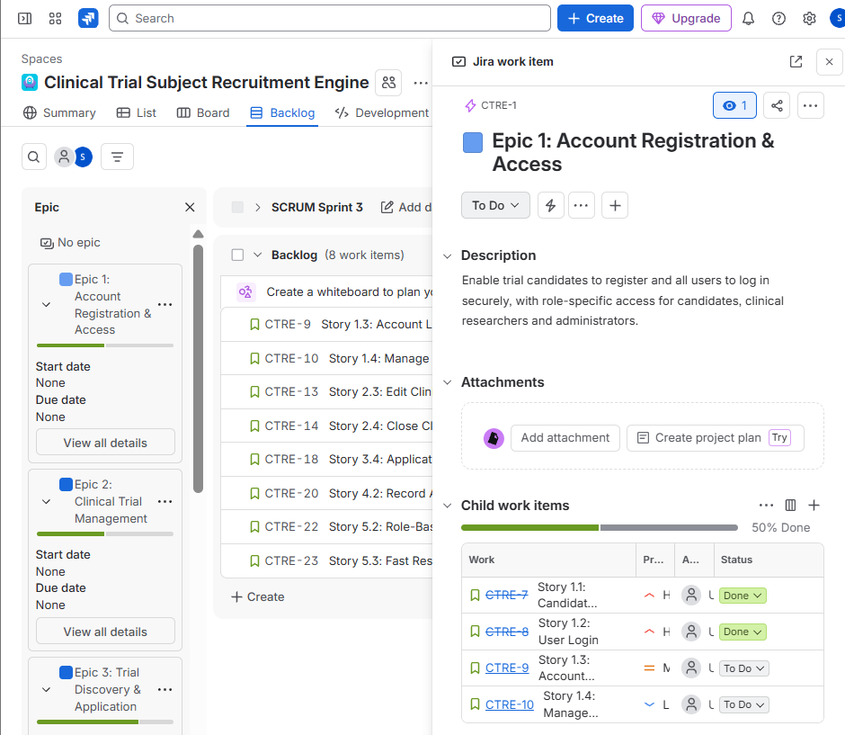
Backlog with an Epic expanded to show its child work items, priorities and statuses.
Figure 3: Sprint 1 completed work items
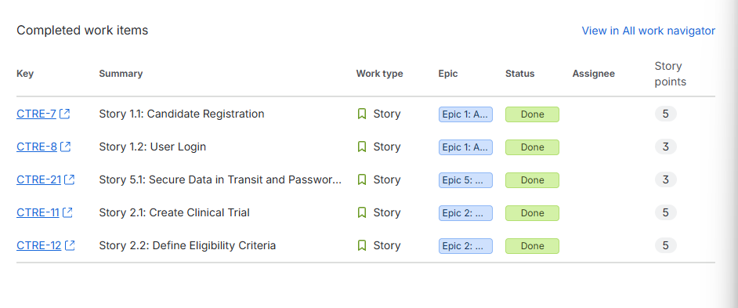
Completed work items for Sprint 1, showing all five stories as Done and their story points.
Figure 4: Sprint 2 completed work items
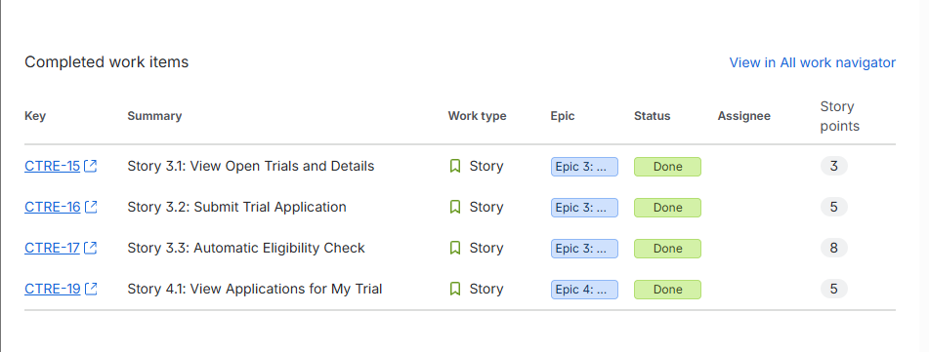
Completed work items for Sprint 2, showing all four stories as Done and their story points.
Figure 5: Sprint 1 Burndown Chart (from Jira)
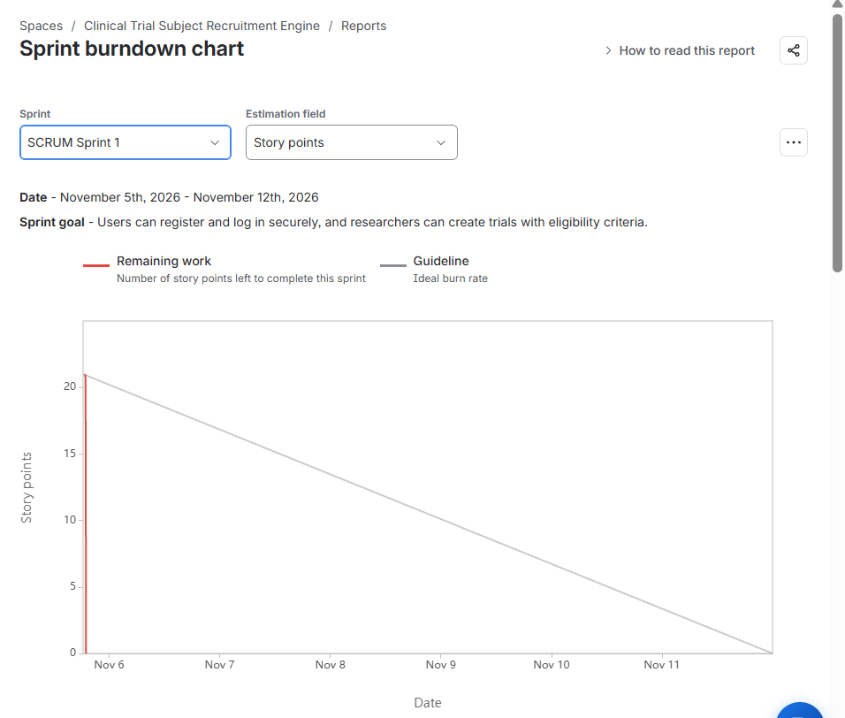
Reports > Burndown Chart, Sprint 1 selected, estimation statistic = Story Points.
Figure 6: Sprint 2 Burndown Chart (from Jira)
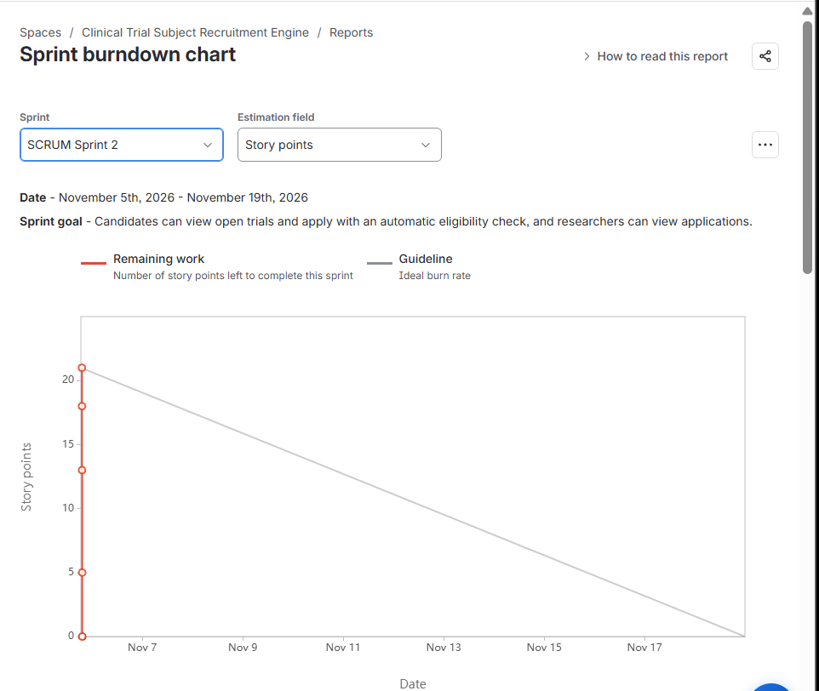
Reports > Burndown Chart, Sprint 2 selected, estimation statistic = Story Points.

8. Reflection Questions

1. Did your estimations reflect the actual effort?
Largely yes, within the limits of a simulation. Each story was sized relative to the others on the Fibonacci scale (planning poker played by one person, using the points-to-time table in the handout as a guide). Small, well-understood stories such as User Login (3 points) received low estimates, and the Automatic Eligibility Check (8 points) received the highest because it combines several rules, error messages and the most uncertainty. The simulated progress followed the same pattern: 3-point stories moved from To Do to Done quickly, while the 8-point story stayed In Progress the longest and was finished only on the last day of Sprint 2. No story had to be re-estimated or split during the two sprints. Because no code was written, the actual effort is represented only by how long each story stayed In Progress. In a real project, the eligibility check would be the first story I would split (rules, messages and tests), and I would calibrate all estimates against measured velocity after a few sprints.

2. Was your backlog well-prioritized?
Mostly yes. Priorities were based on user impact and on the priorities given in the Lab 1 requirements. Registration, login, trial creation, eligibility criteria, trial viewing, application, the eligibility check and application review are High because the recruitment flow does not work without them. Account lock-out, closing a trial, form validation and performance are Medium. Editing a trial and administrator account management are Low because candidates can still be recruited without them. The backlog was ordered by value and by dependency, so Sprint 1 built the base (accounts, basic security, trials with criteria) that Sprint 2 could build on (viewing, applying, eligibility check, reviewing). One weakness is that two High stories, Record Application Decision and Role-Based Access Control, remain in the backlog because the sprint capacity was about 21 points. They are first in line for Sprint 3. Because the data is health-related, I would bring Role-Based Access Control forward in a real project.

3. How did your simulated sprint align with your plan?
The outcome matched the plan. Each sprint committed 21 story points and finished with all committed stories Done: Sprint 1 completed 5 stories (21 of 21 points) and Sprint 2 completed 4 stories (21 of 21 points). No stories were added or removed during either sprint. Progress was not perfectly even. In Sprint 1 nothing was finished on Day 1 because the first two stories were still In Progress. In Sprint 2 the work was back-loaded: 13 of the 21 points were still open until the last day, because the 8-point eligibility check and the researcher review story were completed together at the end. Both sprints delivered their goals: accounts and trial creation in Sprint 1, and trial discovery, application with eligibility check and researcher review in Sprint 2.

4. What insights did the burndown chart give about your team's capacity?
The sprint plan and completed-work-item records show that 21 story points were completed in each sprint. However, the Jira burndown screenshots show the remaining-work markers clustered at the start of the date axis rather than a clear day-by-day downward trend. This means the charts do not provide enough visible timing detail to judge daily capacity or whether progress stayed ahead of the guideline. The simulation was completed, but the burndown evidence is limited because the status changes were recorded too close together in Jira. In a real sprint, I would update work items as work is completed across the sprint days and review the chart regularly. I would also split large stories, such as the 8-point Automatic Eligibility Check, into smaller tasks to make progress easier to track.

Appendix A: Simulated Burndown Charts
These two charts were generated from the progress log in Section 6 to illustrate the expected shape of each sprint burndown (guideline versus remaining story points). They are illustrations, not Jira output. The charts exported from Jira are in Figures 5 and 6.


